OLNA Skill: Converts between units of length to solve a problem

- Calculate the area of the benchtop below. Give your answer in square metres.
Show how you found your answer.
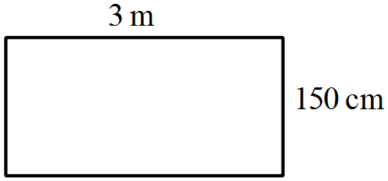

- Use the shape below to calculate how many cm² there are in 1m².
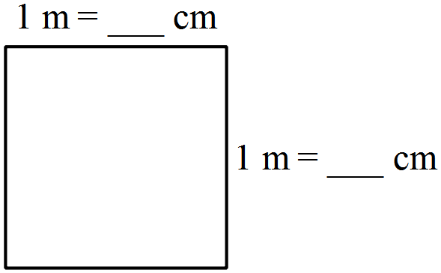

- A carpenter measured a that a door frame has a height of 2 875 mm. The architects plans state that the height should be 3 m.

- By how many mm does the height need to be increased?

- How many cm is this?

- A cycling map has a scale of 1:250 000. The distance between two rest points on the map is 4 cm. How far apart are the rest points. Give your answer in km.

Terminology:

The common units of length are millimetres (mm), centimetres (cm), metres (m) and kilometres (km).
1 cm = 10 mm
1 m = 100 cm = 1 000 mm
1 km = 1 000 m

